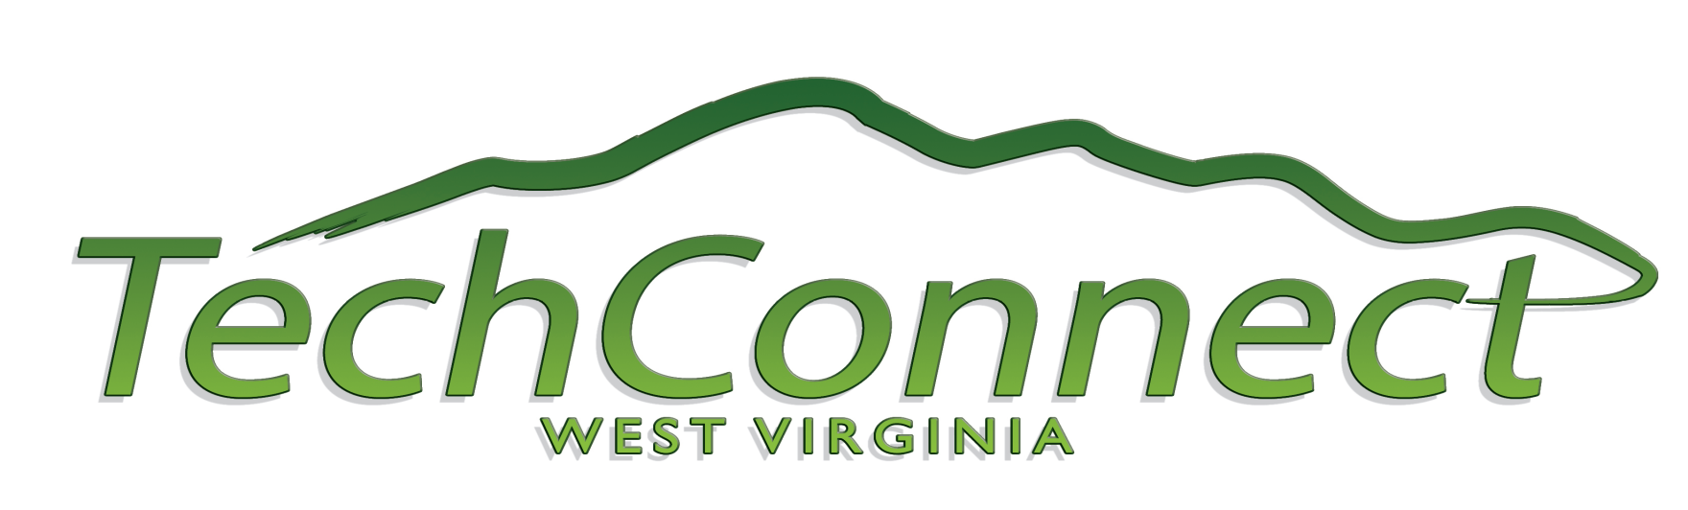
West Virginia Coalition for Technology Based Economic Development

September 13, 2011

REQUEST FOR PROPOSAL

TechConnectWV is issuing this Request for Proposal (RFP) to identify a project manager or firm to assist in the implementation of the West Virginia Blueprint for Chemicals and Advanced Materials.

TechConnectWV released the Chemicals & Advanced Materials Report of the West Virginia Blueprint for Technology-Based Economic Development in August 2011. The report provides detailed information on specific strategies and actions for growing and strengthening West Virginia’s Chemicals & Advanced Materials sectors. Implementing this plan requires cooperation among numerous stakeholders in the state, including academic institutions, industry, federal laboratories, government agencies and not-for-profit organizations.

This RFP solicits a firm or organization with the unique experience and capability to lead implementation efforts of the strategies and action items identified in the Chemicals & Advanced Materials Report.

Execution of this project is contingent upon TechConnectWV identifying and securing funding from public or private sources for this purpose.

Background

TechConnectWV is a coalition of professionals dedicated to growing and diversifying West Virginia’s economy by advancing innovation-based economic development. The organization is a 501(c)3 nonprofit corporation with broad membership from the private, public, higher education, research, and nonprofit sectors. TechConnectWV was created to facilitate the growth of West Virginia’s technology economy and the commercialization of research innovations developed across the state.

The formation and vision for TechConnectWV was based upon three key facts:

- Technology drives national and state economic growth in the United States and provides critical economic diversity
- Technology-based economic development provides more jobs and higher-paying jobs than activities in any other economic sector
- Creation of higher-paying jobs will support growth in every sector of the state economy and will benefit all West Virginians

TechConnectWV’s goals are to diversify the state’s economy, spur creation of high-wage jobs in high-growth industries, and promote economic prosperity. In 2009, TechConnectWV partnered with the Battelle Institute to publish the West Virginia Blueprint for Technology-Based Economic Development. That comprehensive report identified four main platforms as holding the most potential for development in West Virginia: Advanced Energy, Biometrics, Biotechnology and Chemicals and Advanced Materials.

The Chemicals and Advanced Materials sector was selected as one of the four platforms for several reasons, including the presence of a significant number of nonprofit and federal research institutions concentrating in materials science and chemical engineering; core competency strengths including a robust variety of materials such as electronic materials, composites, catalysts, carbon products, and bio-compatible products; potential R&D development of advanced applications for common West Virginia materials and by-products; and challenges facing West Virginia’s large-scale fossil-fuel resource industry that could be met with technological innovations.

In addition, drilling in the Marcellus Shale has opened vast opportunities for revitalizing and transforming the state’s chemical industry. With these factors in mind, the successful proposal will recommend ways to leverage the state’s considerable, existing assets to meet the challenges for growth in this sector.

Scope of Work

Responses to the RFP should address action items to implement the following strategies as identified by the Chemicals and Advanced Materials Blueprint:

- Bring key stakeholders together to guide chemicals and advanced materials development in West Virginia
- Enhance West Virginia’s position in chemicals and advanced materials R&D and associated innovation-based business development
- Leverage assets to achieve industry recruitment and expansion in the cluster
- Assure West Virginia has a world-class workforce able to meet the current and future demands of the cluster

As noted in the Blueprint, the Chemicals and Advanced Materials platform focuses on multiple opportunities in research and development (R&D) and technology development applications related to both traditional and innovative chemicals and materials technologies. Proposals should advance value-added economic activity based on chemicals and materials resources.

In addition, the firm or organization selected will take the lead in preparing a grant application to be submitted by TechConnectWV to seek funding to implement the program.

HOW TO RESPOND TO RFP

To respond to this RFP, please submit a proposal that provides the following information:

- Legal name of submitting organization (and subcontractor organization(s), if any)
- Name and contact information for responsible party for submitting organization
- Summary of the proposals for Blueprint Implementation Plan action items in narrative form
- Project budget for the utilization of funds (up to $160,000 over 18-month period) for the Blueprint Implementation Plan
- Description of organization (including subcontractors) that would work on the Blueprint Implementation Plan
- Plan for private-sector job sustainability of Blueprint Implementation Plan
Responses to the RFI must be submitted, via email, to info@techconnectwv.com by 11:59 pm on September 30, 2011. Questions on this RFP should be directed to TechConnectWV’s executive director, Anne Barth, via email, at anne@techconnectwv.com. More information on TechConnectWV and WV’s Blueprint for Technology-Based Economic Development can be found at www.TechConnectWV.com.

